The title

First Author1 & Ernst-August Doelle1,2

1 Wilhelm-Wundt-University

2 Konstanz Business School

Author note

The authors made the following contributions. First Author: Conceptualization, Writing - Original Draft Preparation, Writing - Review & Editing; Ernst-August Doelle: Writing - Review & Editing.

Correspondence concerning this article should be addressed to First Author, Postal address. E-mail: [my@email.com](mailto:my@email.com)

Abstract

*Keywords:* keywords

*Word count:* X

The title

# 1 Methods

## 1.1 Statistical analyses

regularizing, weakly informative priors (Gelman, Simpson, & Betancourt, 2017)

# 2 Results

## 2.1 Syllabification task

Figure 1 shows stuff.

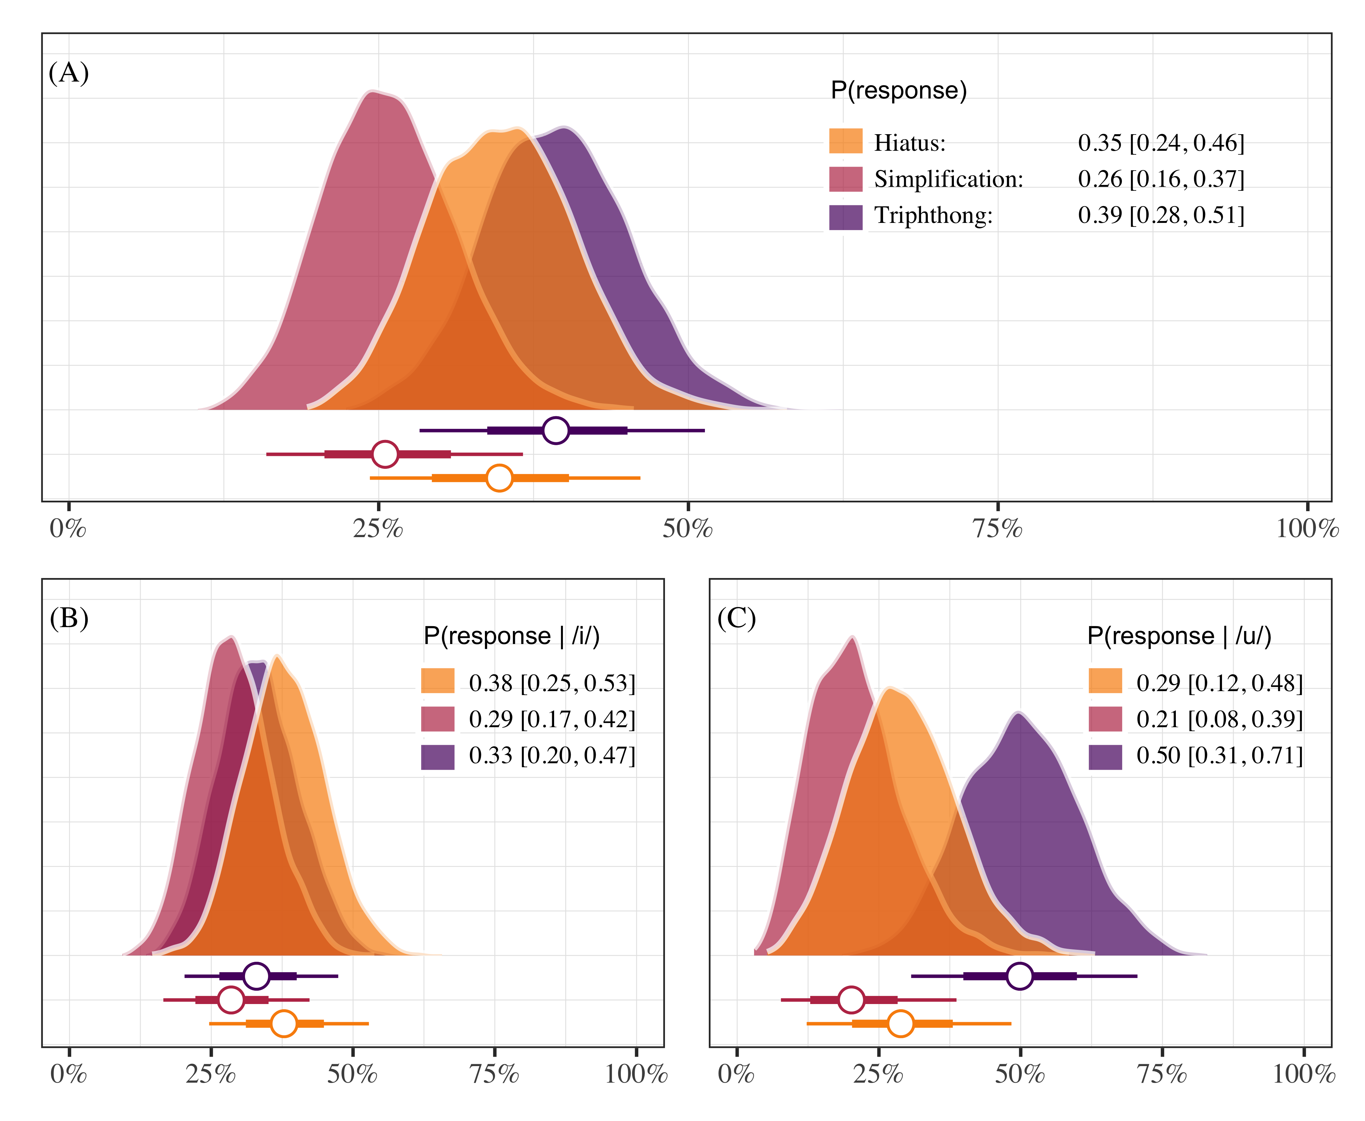

*Figure* *1.*  This is a figure caption.

## 2.2 Carrier task

Table 2 shows a picture table.

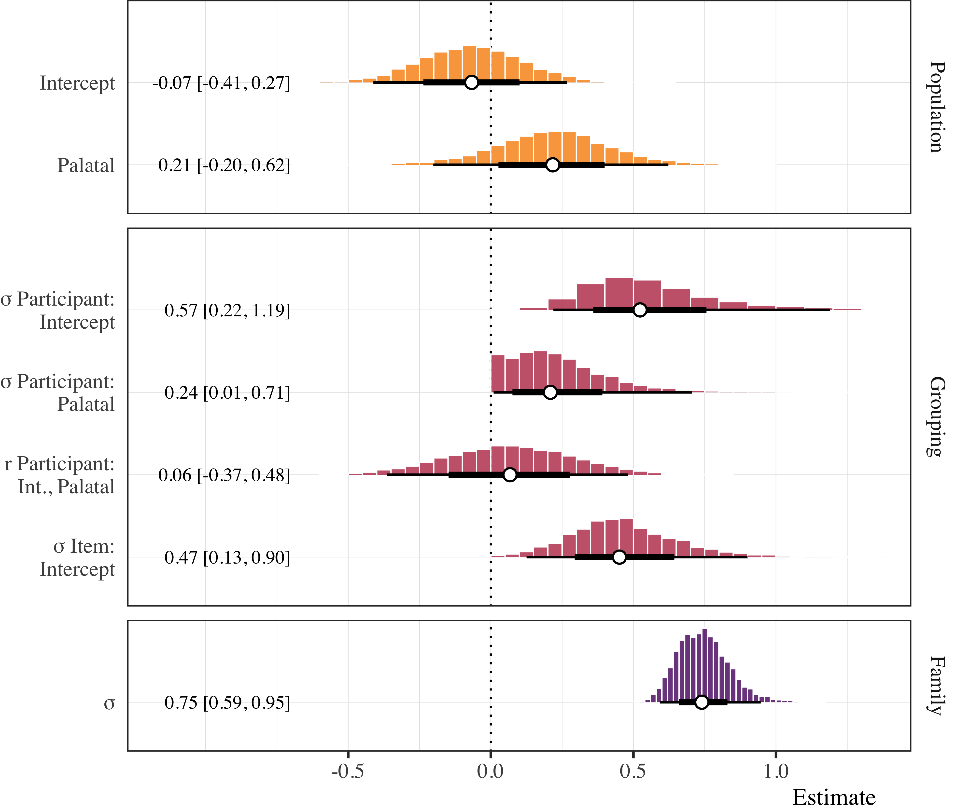

*Figure* *2.*  This is a table caption.

Figure 3 shows the F1 GAM stuff.

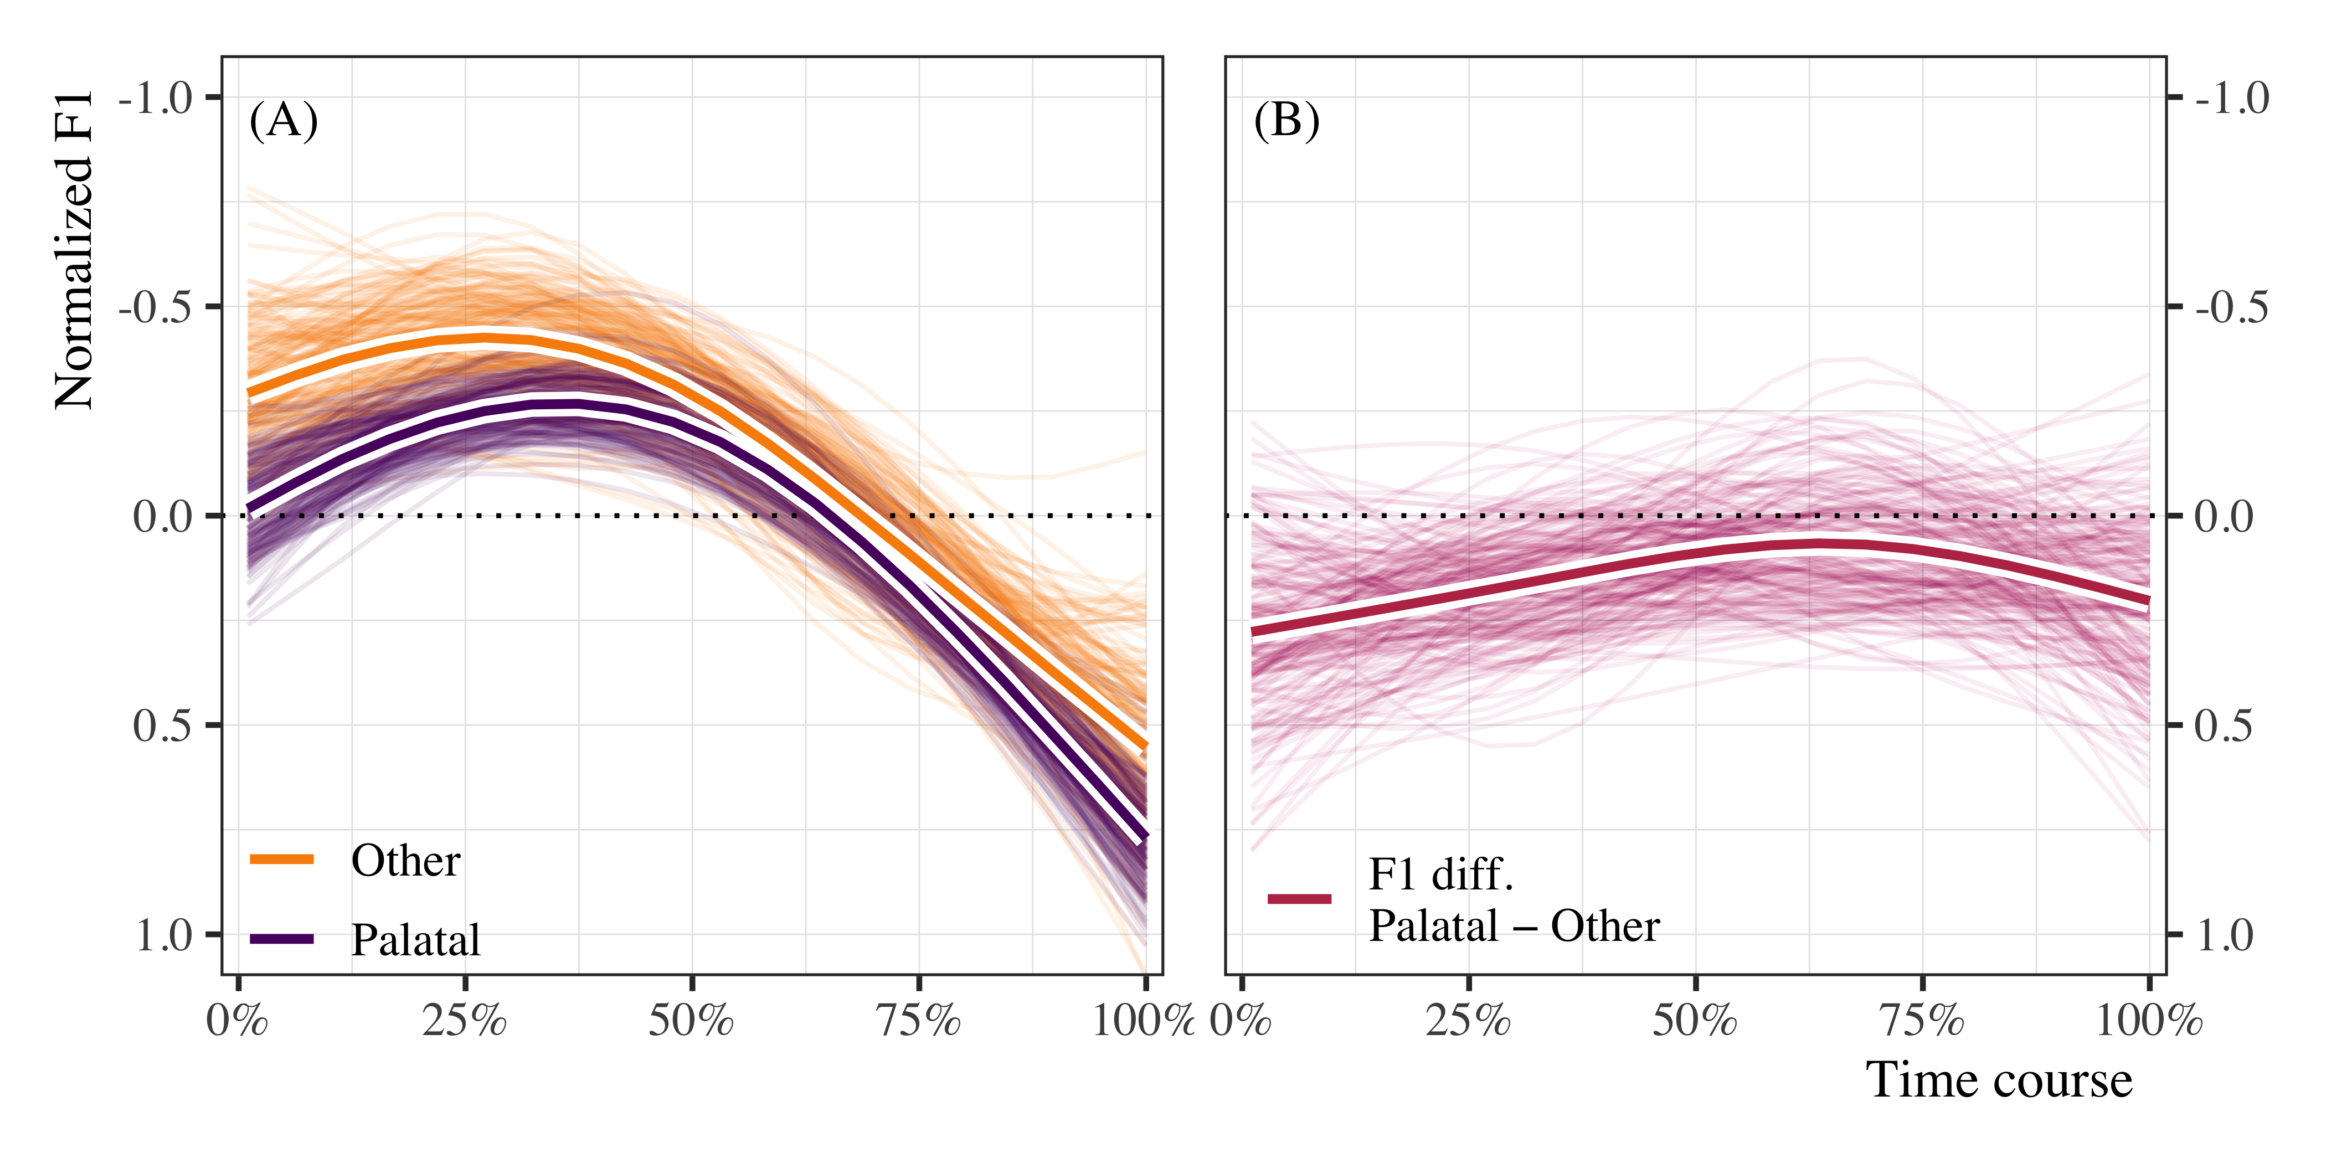

*Figure* *3.*  This is a figure caption for the F1 GAM.

Figure 4 shows the Intensity GAM stuff.

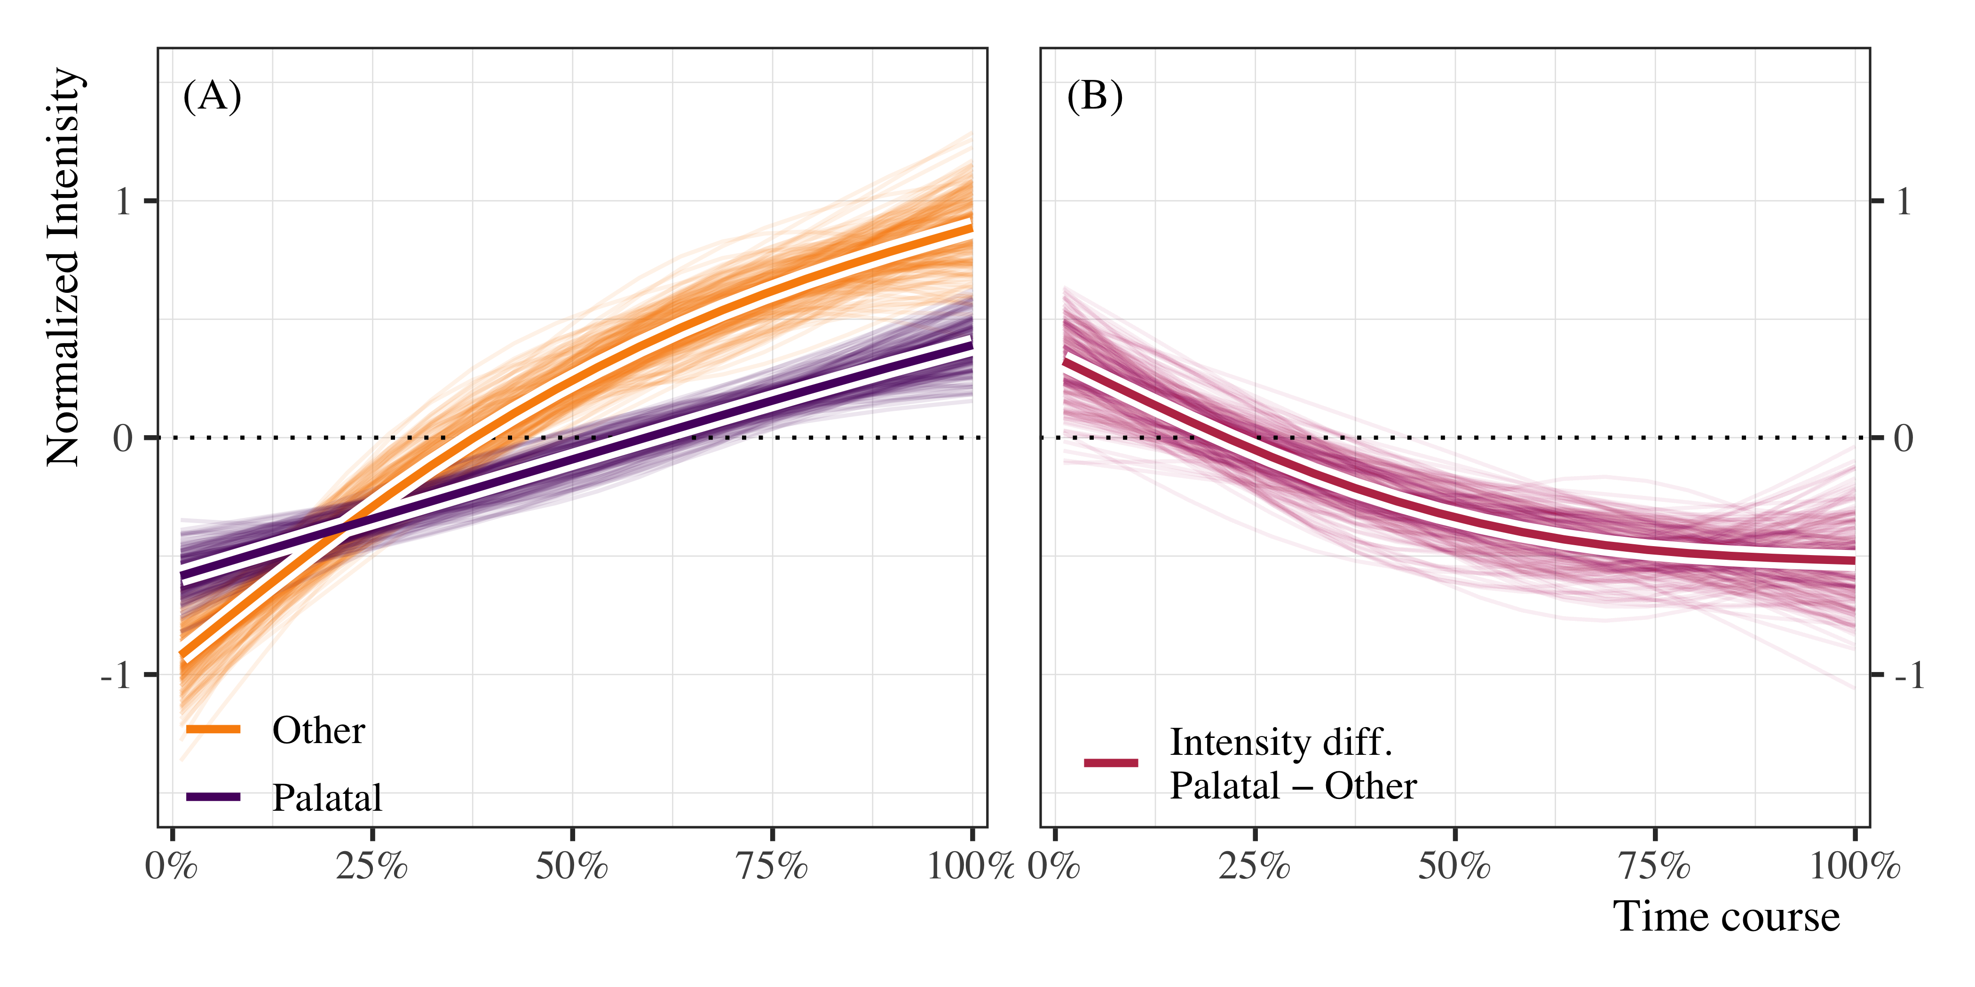

*Figure* *4.*  This is a figure caption for the intensity GAM.

Figure 5 shows the GAM forest plot

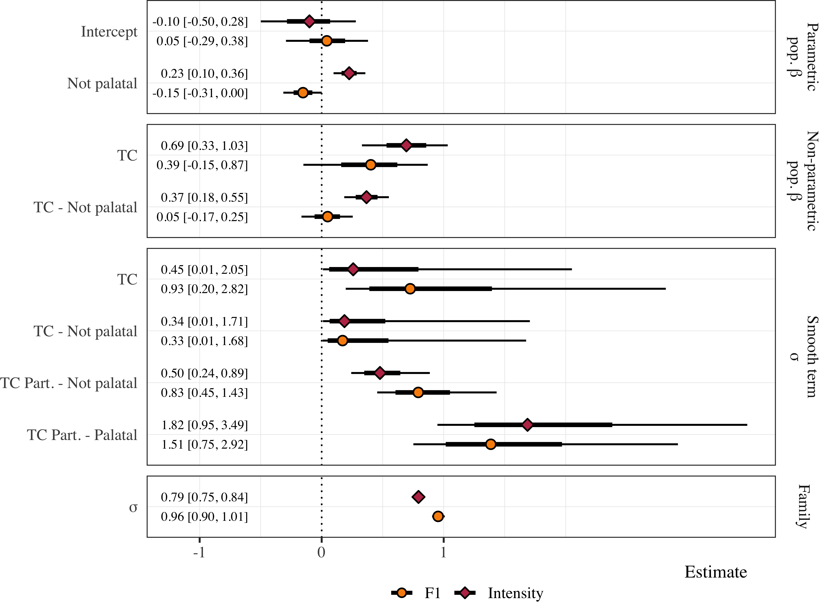

*Figure* *5.*  This is a figure caption for the forest plot of the gams.

# 3 References

Gelman, A., Simpson, D., & Betancourt, M. (2017). The prior can often only be understood in the context of the likelihood. *Entropy*, *19*(10), 1–13. <https://doi.org/10.3390/e19100555>

Appendix

## 3.1 Syllabification task

Table 1 below.

Table 1: Model summary for the syllabification task. The table reports posterior medians, 95% credible intervals, and probability of direction to assess estimates, along with Rhat and Effective sample size to assess model fit.

|  |  |  |  |  |  |  |
| --- | --- | --- | --- | --- | --- | --- |
| Model | Parameter | Estimate | P(direction) | Rhat | ESS | Prior |
| Main | μ Simplification: Intercept | -0.30 [-0.96, 0.29] | 0.84 | 1.00 | 1724.03 | Normal(0, 20) |
| Main | μ Triphthong: Intercept | 0.12 [-0.45, 0.66] | 0.66 | 1.00 | 1974.05 | Normal(0, 20) |
| /i/ | μ Simplification: Intercept | -0.29 [-1.00, 0.47] | 0.78 | 1.00 | 1576.48 | Normal(0, 20) |
| /i/ | μ Triphthong: Intercept | -0.14 [-0.89, 0.52] | 0.65 | 1.00 | 1604.93 | Normal(0, 20) |
| /u/ | μ Simplification: Intercept | -0.37 [-1.61, 0.76] | 0.73 | 1.00 | 1480.26 | Normal(0, 20) |
| /u/ | μ Triphthong: Intercept | 0.54 [-0.42, 1.55] | 0.88 | 1.00 | 1238.82 | Normal(0, 20) |

## 3.2 Carrier task

Table 2 below.

Table 2: Model summary for the duration analysis. The table reports posterior medians, 95% credible intervals, and probability of direction to assess estimates, along with Rhat and Effective sample size to assess model fit.

|  |  |  |  |  |  |
| --- | --- | --- | --- | --- | --- |
| Parameter | Estimate | P(direction) | Rhat | ESS | Prior |
| Intercept | -0.07 [-0.41, 0.27] | 0.65 | 1.00 | 2540.31 | Normal(0, 0.2) |
| Palatal | 0.22 [-0.20, 0.62] | 0.86 | 1.00 | 2091.63 | Normal(0, 0.5) |

Table 3 below.

Table 3: Model summary for the F1 GAMM. The table reports posterior medians, 95% credible intervals, and probability of direction to assess estimates, along with Rhat and Effective sample size to assess model fit.

|  |  |  |  |  |  |  |
| --- | --- | --- | --- | --- | --- | --- |
| Parameter | Function | Estimate | P(direction) | Rhat | ESS | Prior |
| Intercept |  | 0.04 [-0.30, 0.37] | 0.62 | 1.00 | 1241.48 | Normal(0, 0.5) |
| Not palatal |  | -0.15 [-0.31, 0.00] | 0.98 | 1.00 | 5632.28 | Normal(0, 0.5) |
| Time course | Smooth | 0.40 [-0.15, 0.86] | 0.93 | 1.00 | 1617.80 | student_t(3, 0, 1) |
| Time course: Not palatal | Smooth | 0.05 [-0.17, 0.24] | 0.67 | 1.00 | 5176.51 | student_t(3, 0, 1) |

Table 4 below.

Table 4: Model summary for the F1 GAMM. The table reports posterior medians, 95% credible intervals, and probability of direction to assess estimates, along with Rhat and Effective sample size to assess model fit.

|  |  |  |  |  |  |  |
| --- | --- | --- | --- | --- | --- | --- |
| Parameter | Function | Estimate | P(direction) | Rhat | ESS | Prior |
| Intercept |  | -0.10 [-0.48, 0.29] | 0.72 | 1.00 | 1178.24 | Normal(0, 0.5) |
| Not palatal |  | 0.23 [0.10, 0.36] | 1.00 | 1.00 | 5471.15 | Normal(0, 0.5) |
| Time course | Smooth | 0.69 [0.32, 1.02] | 1.00 | 1.00 | 1761.32 | student_t(3, 0, 1) |
| Time course: Not palatal | Smooth | 0.37 [0.20, 0.56] | 1.00 | 1.00 | 4063.34 | student_t(3, 0, 1) |